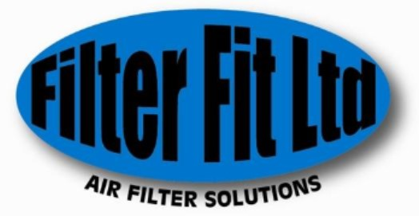

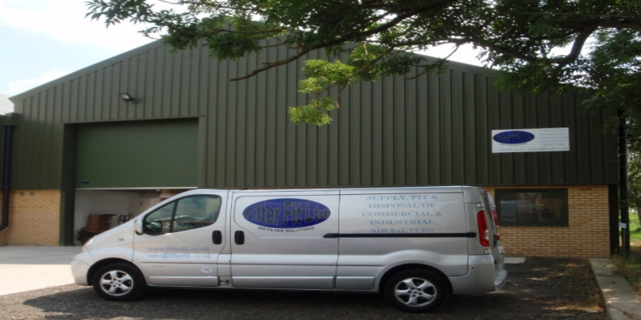

Services

**FilterFit Provide the Following Services**

* Next day delivery on Stock Items
* Certified Fitting and Disposal Service
* Site Surveys
* Filters Packed and Labelled Per Air Handling Units
* National Coverage
* Technical Services
* Duct Cleaning Services
* AHU Inspection and Cleaning
* Planned Preventative Maintenance

Accreditations



We have a gold Constructionline Membership

ID 139442



We are Safe Contractor Accredited



We also won an award from Federation of Small Businesses in 2017 For our efforts of recycling and reducing waste. Ethical Business of the Year “Regional Winner”.

Products

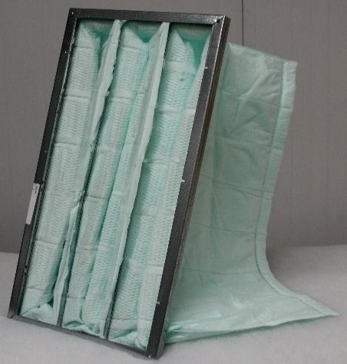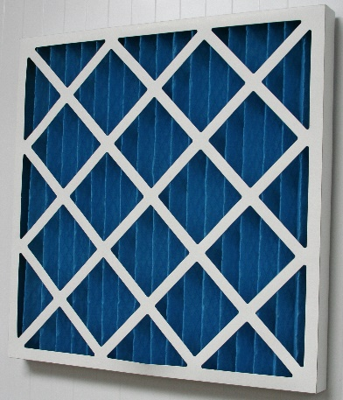

Bag Filters

Made in Various Sizes

Efficiency range from G4, G5 M6 EN779 2012

And also F7 -F9 to Standard ISO16890

Panel Filters

Can Be Made in Various sizes

G4 Efficiency Standard Set by

EN 779 2002

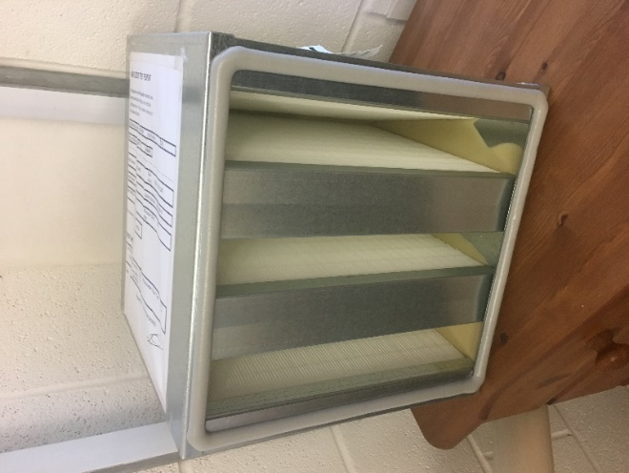

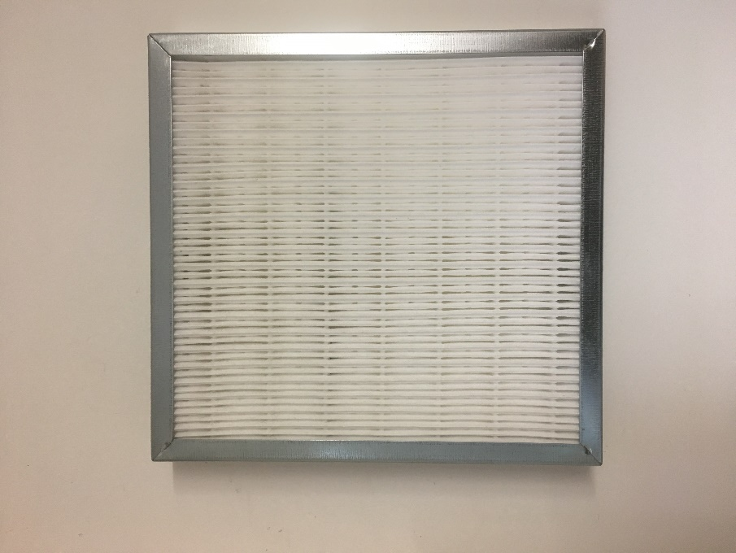

Mini Pleat Filter are A highly Efficient Pre-Filter with a high Dust Holding Capacity.

HEPA Filters Is a Highly Efficient filter that Provides Filtration of 99.9% Of Particles. It will filter Particulates as small as 0.3 microns.

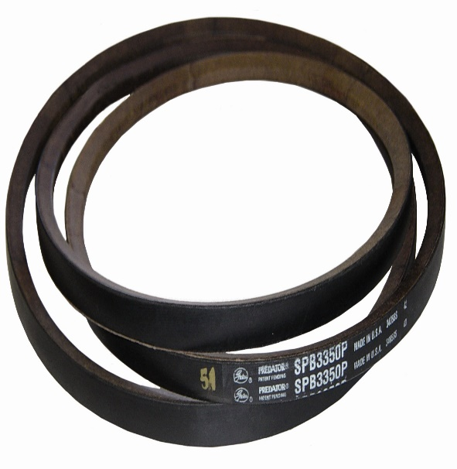

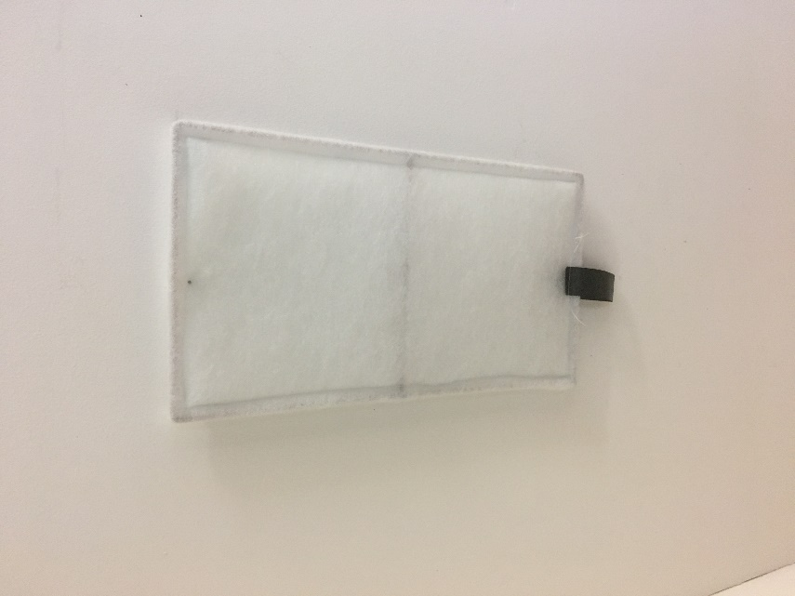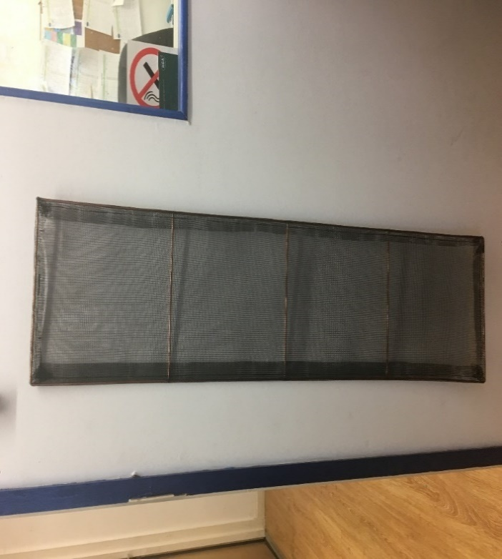

Wire Framed Fan Coils

In Cleanable Nylon (Pictured Left)

Or Disposable Synthetic (Pictured Right)

We Keep a Variety of different sizes of Fan Belts.

Contact Details

Filterfit LTD

Unit 1 Dingley Business Park

Honeybourne Road

Evesham

WR11 7HW

Send enquiries to

Email: Sales@filterfit.co.uk

Telephone: 01386 833330

Or Find us at www.filterfit.co.uk